Charlestown, County Mayo
086 2362839 Email: nmdunleavy@eircom.net
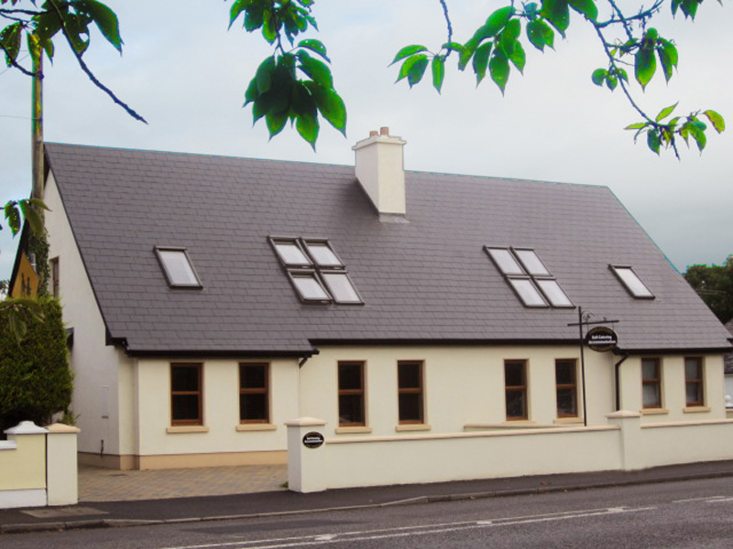

- Sleeps 7
- Wheelchair Accessible
- Ground floor Bedroom
- 5 minute’s drive from Ireland West Airport
- Available all year round
- Ideal base for touring the West of Ireland
- Walking distance to Shops, Bars and Restaurants
- Close to some of Irelands best Coarse Fishing, Angling and Sea Fishing Lakes and Rivers

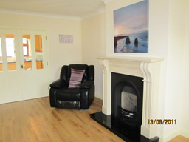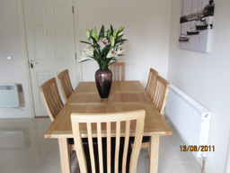

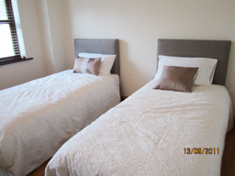

Ground Floor
Kitchen / Dining Room,
Lounge
1 Twin Bedroom
Laundry Room
Toilet & Shower Room

Second Floor
1 Double Bedroom (En-suite)
1Twin Room
1 Single Room
1 Toilet & Shower Room
